Clean up procedure

Only put the following items in the black waste barrels  - Empty paint tubes  - Disposable palette paper  - Oily rags and paper towels  Items that don’t belong in the containers are:  - Plastic bottles  - Coffee cups  - Bio waste  - Etc | 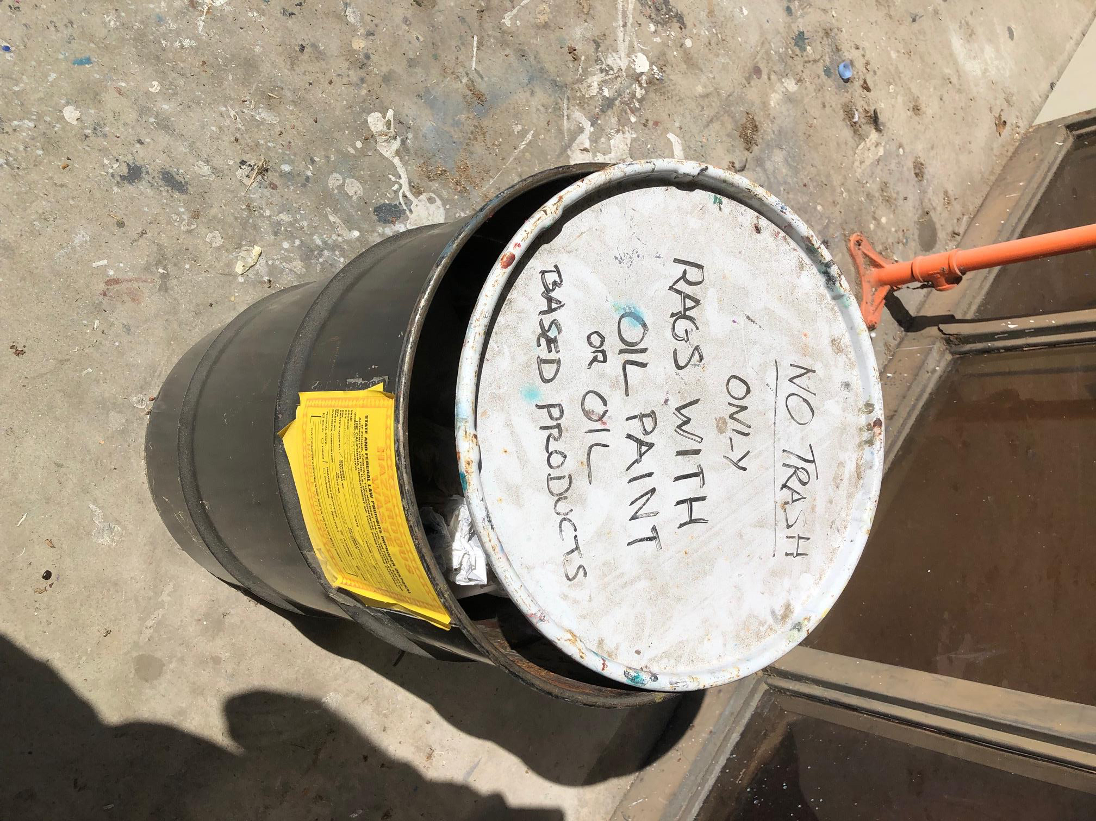
Dispose of Gamsol and other solvents in the black container located in the courtyard by the double gates. | 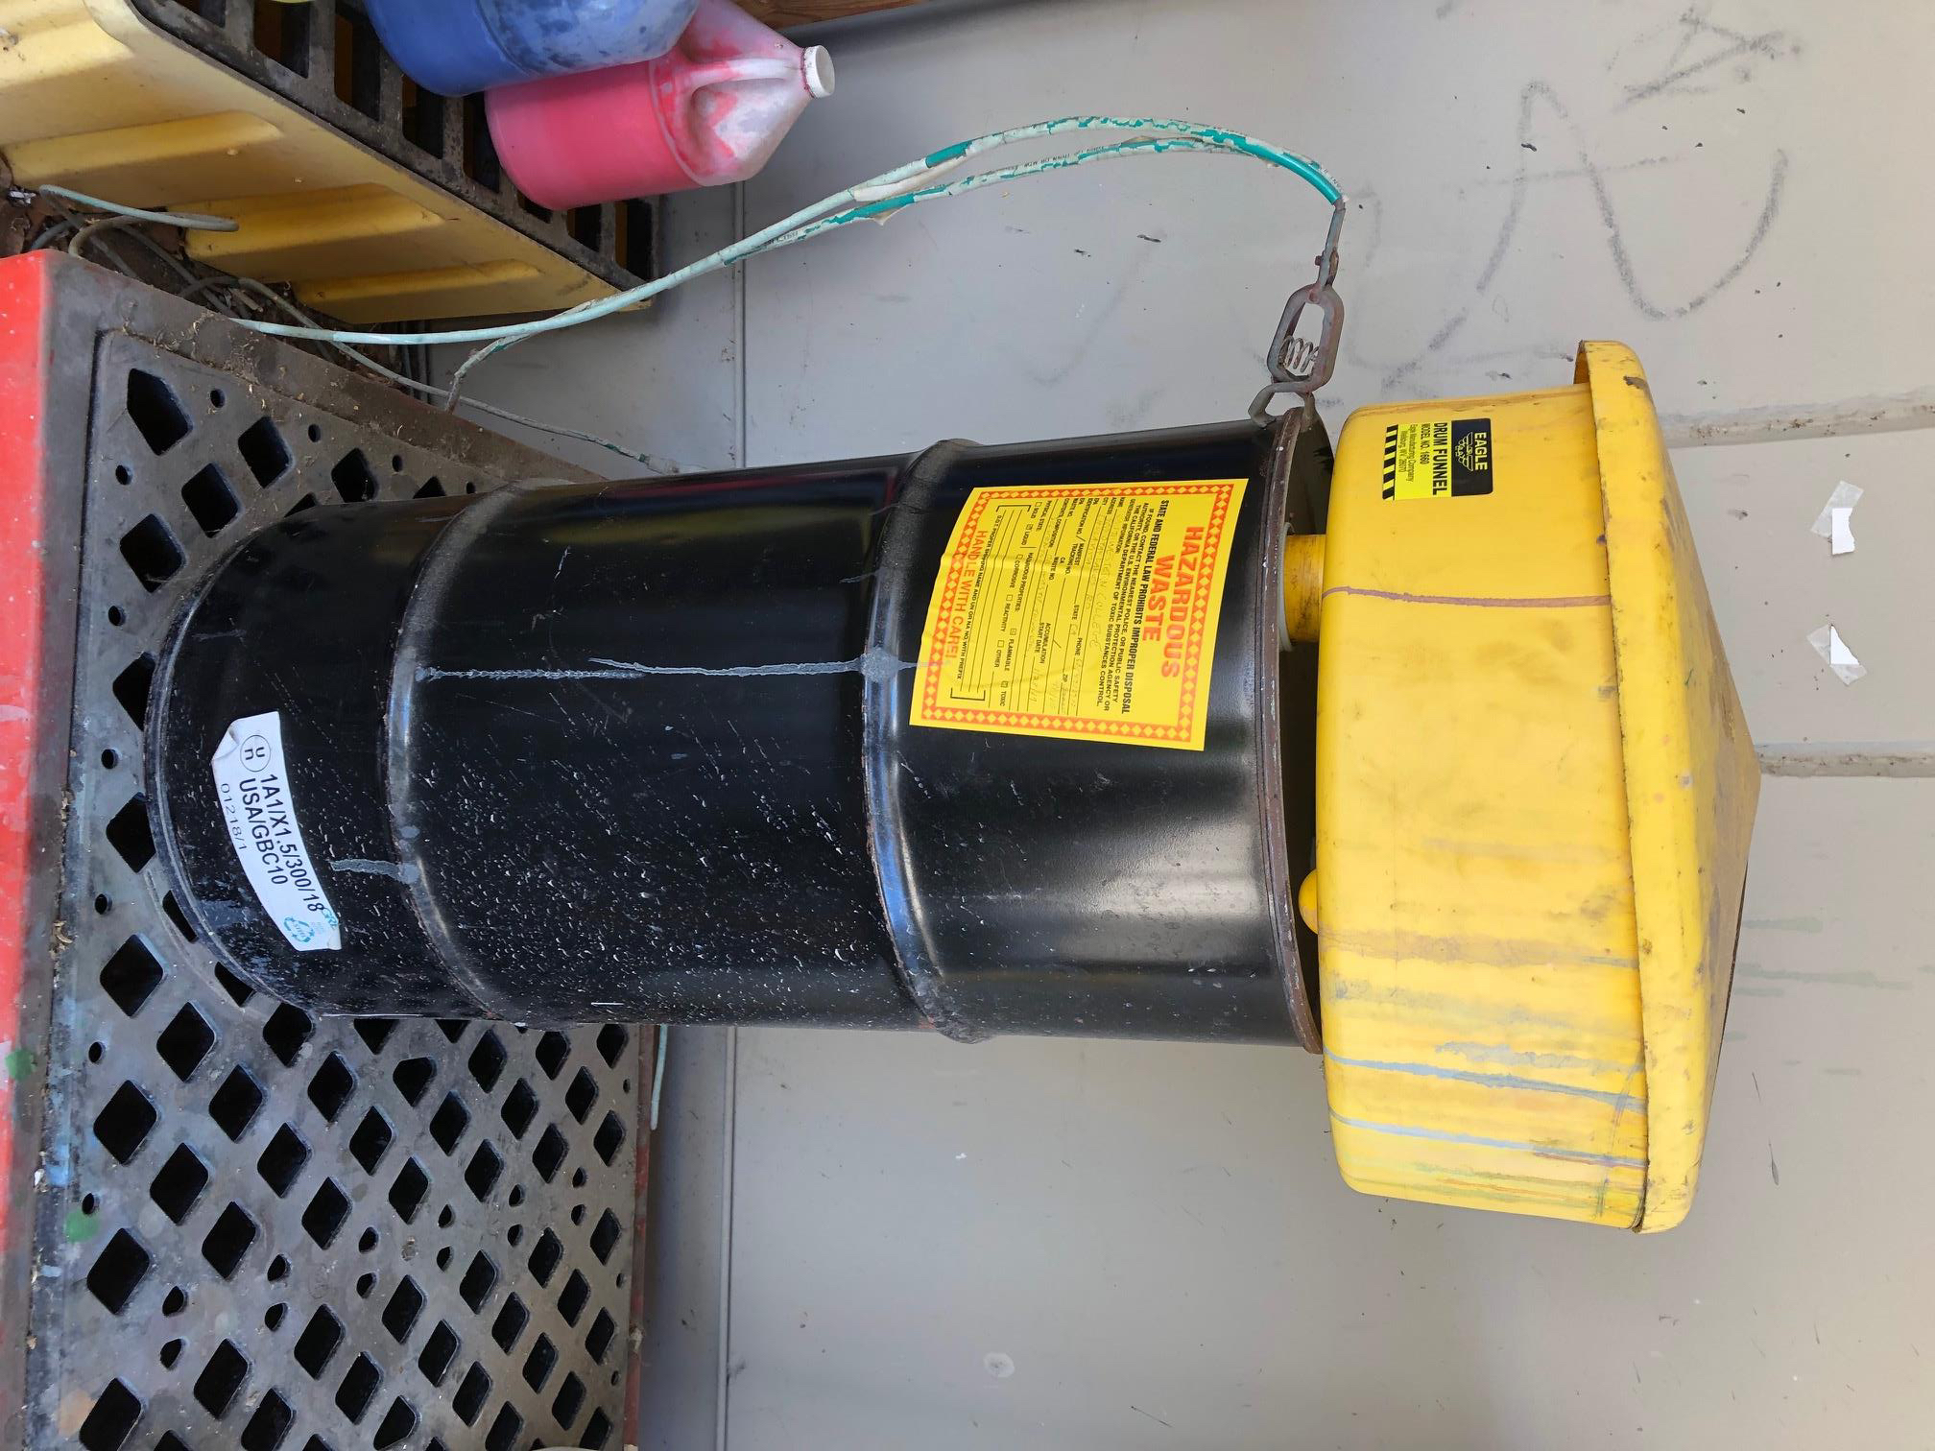

Thank you!
PV

Hues should get lighter as they move from left to right > > > > > > >

Black |  |  |  |  |  |  |  |  | White
Red
Orange
Yellow
Green
Blue
Violet

